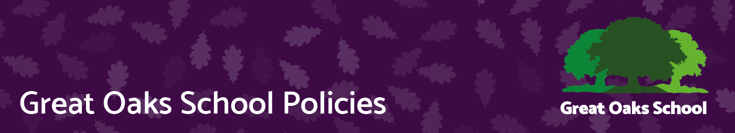
Admissions Policy
Version | 1 | Approved by | Great Oaks Governors
Date last amended | 11th May 23 | Approval date | 16.05.23
Lead officer | Headteacher | Review date | May 2024
Contact | Andy Evans | Effective date | 17.05.23

Rationale
This policy should be read in conjunction with the school’s data protection policy and with Southampton’s Admission to Secondary School website which is available on line at Apply for a school place (southampton.gov.uk). As a Special School, Great Oaks School provides education for students aged 11 to 19 years with clearly identified Special Educational Needs including learning difficulties, and for whom mainstream education is not deemed an appropriate provision. Southampton is the Admission Authority and places students at Great Oaks following a request to the Governing Body.
Southampton has currently agreed with the RSC to fund 320 places at school (rising to 340 in September 23) based on the agreed funding matrix according to their level of Special Educational Need. Students from neighbouring L.A.s may only be admitted should Southampton deem that sufficient places are available.
The vast majority of students will be admitted on the basis of an Educational Health Care Plan of Special Educational Need and Disability which names Great Oaks. However, from time to time the LA arranges for students to be admitted for a period of assessment, for example if a student is new to the country. A statutory assessment is then initiated after a settling period by the Local Authority.
Most students will come to Great Oaks on a full time basis. In line with its Equal Opportunity Policy, Great Oaks is a fully inclusive organisation admits students irrespective of gender, sexual orientation/identity, disability, race or belief.

Admission Procedures at Great Oaks
Transfer to Great Oaks from Mainstream School in Key Stage 3 , 4 or 5
Each year a number of students from Southampton’s Primary Special Schools transfer to Great Oaks at the end of Year 6. In addition, students may be admitted to Great Oaks at different ages or from a variety of other schools (subject to place availability), which include mainstream Primary or Secondary School within Southampton and mainstream or Special schools outside Southampton LA.
Following discussion at City wide panel meetings Southampton will consult with Great Oaks School for a place at the school. The local Authority will need to determine that “where there is agreement that the placement is compatible with identified special educational needs, compatible with the education of others with whom they will be educated and compatible with the efficient use of resources” and if it is determined that a place is available then, following consultation with the school, a place will be made available.

Transition Arrangements
All Parents/carers and potential pupils are invited to visit the school prior to any decision regarding placement. Great Oaks puts on 3 Open Mornings a year to enable to families to visit and find out about the school. At these Open Mornings we can signpost parents to relevant support services.
All students transferring into Year 7 from the Primary Special and Mainstream Schools are afforded the opportunity to participate in a transition programme during the Spring and Summer term of Year 6. This will include visits by staff to current schools and transition days at Great Oaks. Pupils transferring into the sixth form or at other points in the year will have a bespoke transition plan following discussion with families and current school.

