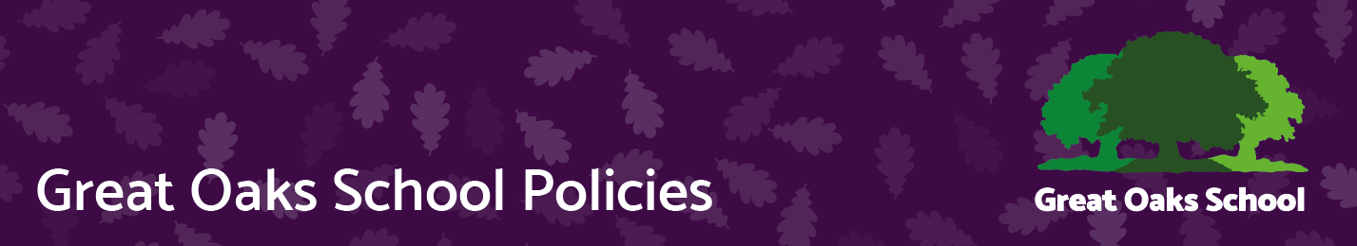
British values
Version | 6 | Approved by | Great Oaks Governors
Date last amended | March 2023 | Approval date | 14.03.23
Lead officer | Head Teacher | Review date | March 2024
Contact | Andy Evans | Effective date | 15.03.23

Promoting British Values at Great Oaks School

March 2023

The Department for Education state that there is a "need to create and reinforce a clear and rigorous expectation on all schools to promote the fundamental British values of democracy, the rule of law, individual liberty and mutual respect and tolerance of those with different faiths and beliefs".

The government set out its definition of British values in the 2011 Prevent Strategy.

At Great Oaks School these values are taught and reinforced regularly through a broad and balanced curriculum including PSHE, Citizenship, RE, Collective Worship, humanities and the arts and through planned themes throughout the year. Examples through the planned curriculum include:

History - slavery, holocaust
Geography - Other countries and cultures Japan, Kenya, Brazil
The Arts – music, art and literature from different cultures

We take opportunities to promote British values through our assemblies and whole school themes and structures such as electing the student council. Through a well-planned curriculum which includes opportunities to explore these values. These must be planned carefully and differentiated to meet the broad and complex range of learning need of the students.

The British values are defined as:
- Democracy
- Rule of Law
- Individual Liberty
- Mutual Respect
- Tolerance of those with different faiths and beliefs

Democracy
Democracy is an important part of the school. Each new academic year student council members are democratically elected. Regular student council meetings give all students a voice. These are given an agenda which is shared with classes prior to the meeting. Minutes are made available to all pupils.

- Student council
- Student council elections
- Student surveys
- Local and national elections give an opportunity to learn more about pupils voice

Rule of Law

- School rules
- School code
- Behaviour Code
- Law and Justice – including working with visitors including local police

Rules of law start with the classroom and the school. These are regularly reinforced. Laws of the country and the roles of law enforcers are taught and reinforced. The behaviour code includes rules and sanctions. Students are aware of these and consequences for their actions. Students are taught the values and reasons behind laws. Visits from authorities such as police and fire service are regular parts of the calendar and reinforce learning.

Individual Liberty
We provide a safe and secure environment in which all pupils are able to learn. Pupils are encouraged to know their rights and responsibilities. They are advised how to exercise their personal freedoms safely:
e.g. Through Citizenship, PSHE and e-safety.
Pupils are given the freedom to make choices:
e.g. Friday afternoon activities, lunchtime clubs and KS4 curriculum choices.

Mutual Respect
Respect is a core value of the school. Respect for one another and respect of our differences and how we all have a voice and we are all equal. Fairness for all is implemented through teaching and learning, access to facilities and activities. We firmly believe that although we are all different we are all equal.

Tolerance of those with Different Faiths
Students learn about different faiths through RE days every half term, through news items, and through assemblies. We learn about other faiths and cultures through celebrating international events such as the World Cup and the Olympics. We raise awareness through charity days including Red Nose Day and through promoting local, national and international charities. Currently we are supporting a school in Zambia. We fundraise for others through these activities and fundraising for those of different cultures. We have 19% ethnic minority and 11 different languages. We welcome visitors and performers from other cultures, we visit places of worship from different religions. We take anti-bullying very seriously including bullying people because they are perceived to be different. These differences and similarities are explored in a joint British Values and Modern Foreign Languages Week. Where students have time to discuss and learn about the very varied and diverse cultures and languages that make up modern Britain.

Assessment and Recording
Pupil work will be marked and assessed in line with policy for all curriculum areas. Involvement and support with extra-curricular activities will be recorded with certificates, through newsletters, photographs and whole school celebrations and activities (e.g. Sports Relief; RE days).

Links to other Policies
Equality Scheme, Anti-racism, Anti-bulling, Behaviour Policy, Curriculum Policy, PSE & Citizenship

Appendix 1 - Respect Statement
The Statement below taken from the British values Policy and based upon our Mission Statement was written in 2016 and is displayed prominently in school.

Statement of Equality, Respect and Inclusion 2022-2023
At Great Oaks School we are committed to ensuring equality of education and opportunity for all pupils, staff, parents and carers receiving services from the school irrespective of race, gender, disability, nationality, faith or religion or socio-economic background.
- We aim to develop a culture of inclusion and diversity in which all those connected to the school feel proud of their identity and are able to participate fully in school life.
- Our mission statement talks of the importance of recognising diversity within our school.
- We promote British values throughout the curriculum. At the heart of British values are mutual respect for and tolerance of those with different faiths and beliefs and for those without faith
- We welcome students and staff from all sectors of the community and believe that the diversity they bring enhances the life at the school.

