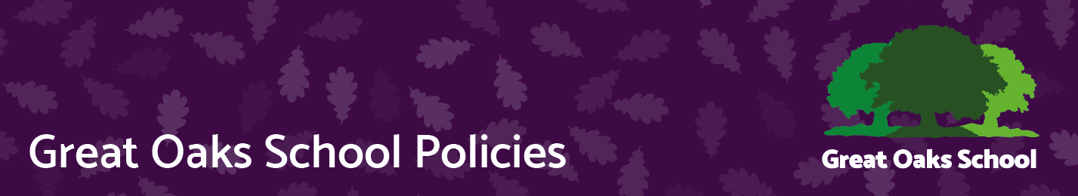
Equal opportunities
Version | 5 | Approved by | Great Oaks Governors
Date last amended | May 2023 | Approval date | 16.05.2023
Lead officer | Head teacher | Review date | 2026
Contact | Andy Evans | Effective date | 17.05.2023

Aims

Great Oaks is an inclusive school and works with all its staff and families to ensure that everyone is treated with dignity and respect and that individual differences are supported and recognised.
We meet our obligations under the public sector equality duty by having due regard to the need to:
- Eliminate discrimination and other conduct that is prohibited by the Equality Act 2010
- Advance equality of opportunity between people who share a protected characteristic and people who do not share it
- Foster good relations across all characteristics – between people who share a protected characteristic and people who do not share it

Legislation and guidance
This document meets the requirements under the following legislation:
- The Equality Act 2010, which introduced the public sector equality duty and protects people from discrimination
- The Equality Act 2010 (Specific Duties) Regulations 2011, which require schools to publish information to demonstrate how they are complying with the public sector equality duty and to publish equality objectives
- This document is also based on Department for Education (DfE) guidance: The Equality Act 2010 and schools.

Roles and responsibilities
The Trustees of SSET and LGB will;
- Ensure that the equality information and objectives as set out in this statement are published and communicated throughout the school, including to staff, pupils and parents, and that they are reviewed and updated at least once every three years
- Delegate responsibility for monitoring the achievement of the objectives on a daily basis to the headteacher
- Ensure they’re familiar with all relevant legislation and the contents of this document
- Attend appropriate equality and diversity training
- Report back to the full governing board regarding any issues

The Headteacher will:
- Promote knowledge and understanding of the equality objectives amongst staff and pupils
- Monitor success in achieving the objectives and report back to governors
- All school staff are expected to have regard to this document and to work to achieve the objectives as set out in section 8.

Eliminating discrimination
- We are aware of our obligations under the Equality Act 2010 and complies with non-discrimination provisions.
- All relevant policies and codes of conduct include reference to the importance of avoiding discrimination and other prohibited conduct.
- Staff and governors are regularly reminded of their responsibilities under the Equality Act, for example during meetings. Where this has been discussed during a meeting it is recorded in the meeting minutes.
- Pupils are taught to treat each other with respect across school and cover diversity issues through PSHE and citizenship lessons

Advancing equality of opportunity
As set out in the DfE guidance on the Equality Act, we aim to advance equality of opportunity by:
- Removing or minimising disadvantages suffered by people which are connected to a particular characteristic they have (e.g. pupils with disabilities, or gay pupils who are being subjected to homophobic bullying)
- Taking steps to meet the particular needs of people who have a particular characteristic (e.g. enabling Muslim pupils to pray at prescribed times)
- Encouraging people who have a particular characteristic to participate fully in any activities (e.g. encouraging all pupils to be involved in the full range of school societies)
In fulfilling this aspect of the duty, the school will:
- Publish attainment data each academic year showing how pupils with different characteristics are performing
- Analyse the above data to determine strengths and areas for improvement, implement actions in response and publish this information
- Make evidence available identifying improvements for specific groups (e.g. declines in incidents of homophobic or transphobic bullying)
Fostering good relations
We aim to foster good relations between those who share a protected characteristic and those who do not share it by:
- Promoting tolerance, friendship and understanding of a range of religions and cultures through different aspects of our curriculum. This includes teaching in RE, RSE, citizenship and personal, social, health and economic (PSHE) education, Preparation for adulthood, but also activities in other curriculum areas. For example, as part of teaching and learning in English/reading, pupils will be introduced to literature from a range of cultures.
- Covering issues of diversity and respect through whole school themed weeks and Assemblies Pupils will be encouraged to take a lead in such assemblies and we will also invite external speakers to contribute.
- Working with our local community. This includes inviting leaders of local faith groups to speak at assemblies and organising school trips and activities based around the local community.
- Encouraging and implementing initiatives to deal with tensions between different groups of pupils within the school. For example, our school council has representatives from different year groups and is formed of pupils from a range of backgrounds. All pupils are encouraged to participate in the school’s activities, such as sports clubs. We also work with parents to promote knowledge and understanding of different cultures.

Equality considerations in decision-making
We ensure we have due regard to equality considerations whenever significant decisions are made.
- The school always considers the impact of significant decisions on groups. For example, when a school trip or activity is being planned, the school considers whether the trip:
- Cuts across any religious holidays
- Is accessible to pupils with the range disabilities and SEN at the school.
- Has equivalent facilities for boys and girls.

Equality objectives
Objective 1: Review the ethnic diversity and gender make-up of the workforce at Great Oaks, making recommendations for action to the Trust HR committee
Objective 2: Ensure that we are able to continue to effectively monitor progress of different pupil groups through the Earwig assessment framework and target interventions to groups not making progress

Objective 3: Work with the Local Authority to ensure that all the new school buildings being planned is accessible for pupils and staff with any disability or access issue
Objective 4: To work across the Trust to ensure that the Governance of the Trust and individual schools is representative of the community that it serves.

9. Monitoring arrangements
The Governing Body will update the equality information we publish, at least every year.
This document will be reviewed by the Governing Body at least every 3 years.
This document will be approved by the Governing Body and the Trustees

