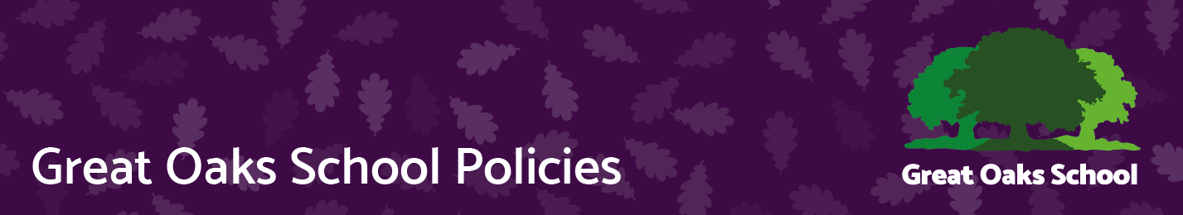
Preparation for Adulthood
Version | 1 | Approved by | Great Oaks Governors
Date last amended | Created March 2023 | Approval date | 14.03.23
Lead officer | Assistant Headteacher for Great Oaks College | Review date | March 2025
Contact | Kate Henty | Effective date | 15.03.23

Definition

The term “Preparing for Adulthood” is used to describe the process of moving from childhood into adult life. It is used by professionals to describe the changes in services when a child becomes an adult. However, this transition can happen at different times for different families.

At Great Oaks everything we do aims to support our children and young people to have active fulfilling lives as adults.

The Special Educational Needs and Disability Code of Practice 2015 emphasises Preparing for Adulthood from the earliest years, and there are some very important, specific statutory requirements that must be covered at the year 9 review.

Sections 8.9, 8.11, 9.150, 8.18 and 8.8 specify that:

Planning & Outcomes:

Employment – Independent living – Community inclusion- Health

The outcomes are aspirational and our role as educators of children and young people with complex needs is to navigate a meaningful and realistic pathway that is both challenging and respectful. A pathway that enables full and active participation in their communities, whether that is through paid employment, voluntary work, further education or with access to engaging and relevant activities, that support their mental health and wellbeing into adulthood.

•There must be a focus on Preparing for Adulthood

• The discussions must centre on the young person

• The young person’s aspirations and what they want to achieve must be explored

• The revised EHC plan must include outcomes that are ambitious, stretching and
will prepare the young person for adulthood

• Outcomes should be ambitious and show how they will enable young people to
make progress towards their aspirations

• Young people should have the support they need to fully participate in this planning
and decision making

For our children and young people using ImPACTS please see Appendix 1 Suggested Outcomes for all Key skill areas. These have been written to ensure all of the above are in place and are linked to the ImPACTS key skill areas and Preparation for Adulthood.

The year 9 review will identify:

- The support the young person needs to achieve their aspirations

- What will their education look like from age 16 so that they can prepare for adult life

- How the young person wants their support to be delivered and the support they need to make more decisions for themselves

- Expectations need to be realistic and reassuring for families.

Our children and young people may need support from an independent skilled supporter to ensure their views are acknowledged and valued. They will need support in expressing or having their views considered, with regard to:

• Education
• The future they want in adult life
• How they prepare for adult life
• Health
• Where they live
• Their relationships
• Their finances
• Participation in the community
• How they will achieve greater autonomy and independence

This role can be undertaken by family members and friends or by an advocate. In Southampton we use Voiceability and a referral can be made by the family or any other professional involved with the child or young person. VoiceAbility | Make a referral

What Does This Mean In Practice?

In order to fulfil the statutory requirements outlined above, it is essential that the year 9 review meeting is person-centred. The approach should use the following key questions to guide a collective conversation which everyone can contribute to:

- What do people like and admire about this young person?
- Who are the important people in your life?
- What is important to you – now and in the future?
- What is important for you – now and in the future?
- What is working well?
- And not so well in your life at the moment?
- What support and help do you need?

In the year 9 review it is important to help families reframe their responses to consider the next steps for their children.

Who Is Going to Do What & By When?

This conversation will result in information that will lead to developing outcomes that will take the young person towards their aspirations for life and identify the support they need.

Sometimes this process will highlight bigger issues or questions that cannot be addressed in the EHCP process and should form part of an action plan for follow up meetings and or identifying the source of possible support or answers.

In years 9 10 and 11 Great Oaks students will have targeted individual support to help them plan their next steps into adulthood, through education training or access to adult services. This support will happen outside of the review process but will feed into it each year.

Post 16

Post 16 Intent for learning and teaching

- To equip students for adult life by increasing independence and reducing dependency on others, increasing self-confidence, promoting self-advocacy and emotional resilience through a wide range of learning opportunities on site and in the wider community.

- To provide a functional curriculum that inspires and enables all students to explore and gain skills to prepare them to be active participants in their own futures and the wider community.

- Post 16 develops employability, independent living skills, community inclusion and health and wellbeing for our young people linked to the preparation for adulthood outcomes.

- Students are supported to recognise their own strengths, skills, and areas for development.

This policy should be read in conjunction with:

Carers statement
Curriculum policy

Appendix 1

Post 16 Curriculum documentation

Our Curriculum
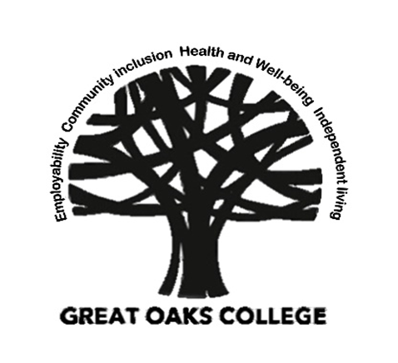
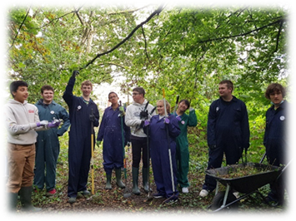
Page | Contents
2 | Post 16 Intent for learning and teaching
3 | Education and Health Care Plans
4 | The curriculum and Preparation for adulthood
5 | Employability statement of intent
6 | Community inclusion statement of intent
7 | Health and Wellbeing statement of intent
8 | Independent living statement of intent
9 | Assessment and Accreditation
10 | Passport to Adult Living
11 | Destinations
Post 16 Intent for learning and teaching

- To equip students for adult life by increasing independence and reducing dependency on others, increasing self-confidence, promoting self-advocacy and emotional resilience through a wide range of learning opportunities on site and in the wider community.

- To provide a functional curriculum that inspires and enables all students to explore and gain skills to prepare them to be active participants in their own futures and the wider community.

- Post 16 develops employability, independent living skills, community inclusion and health and wellbeing for our young people linked to the preparation for adulthood outcomes.

- Students are supported to recognise their own strengths, skills, and areas for development.

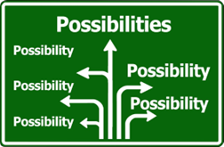

- We ensure that the education that our young people receive is adapted to meet their individual needs and relevant to the demands and contexts of both their local communities and wider world.

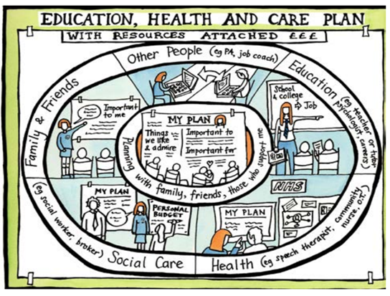
EHCP
All our young people have an Education Health and Care plan.
The Special Educational Needs and Disability Code of Practice 2015 (SEND) emphasises Preparing for Adulthood from the earliest years.

In Post 16 we will work with the family and young person to ensure that their plan and outcomes are preparing them for their adult lives.

The outcomes are aspirational and our role as educators of children and young people with SEND, is to navigate a meaningful and realistic pathway that is both challenging and respectful. A pathway that enables full and active participation in their communities, with access to engaging and relevant activities, that support their mental health and wellbeing into adulthood.

All students are supported to prepare a personalised PowerPoint for their review, with photos and evidence linked to the Preparation for adulthood outcomes and curriculum.

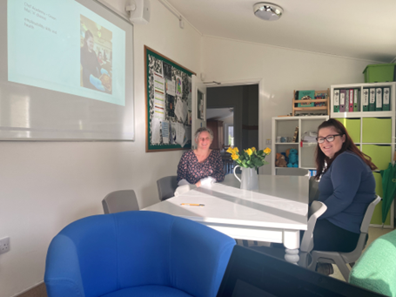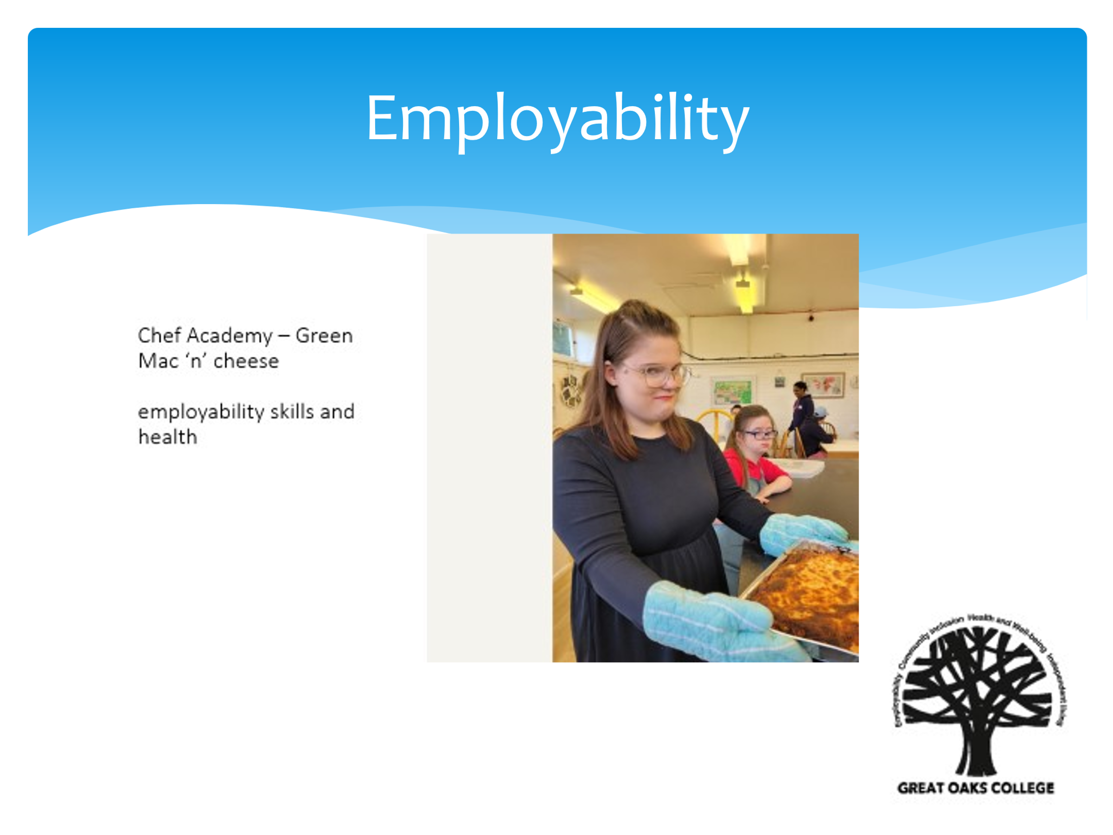

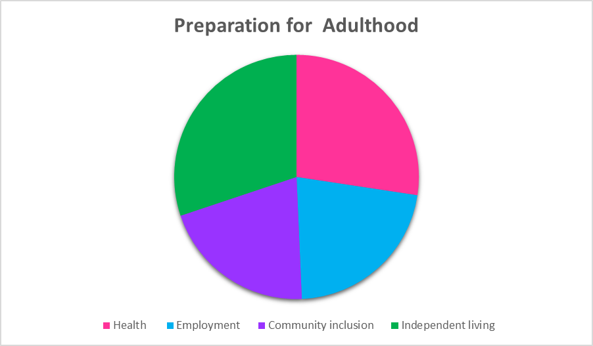
At the review we identify what the next steps are towards the outcomes and how we continue to prepare them for their adult lives, shifting the focus according to the needs and aspirations of the young person.

The Curriculum
Preparation for Adulthood
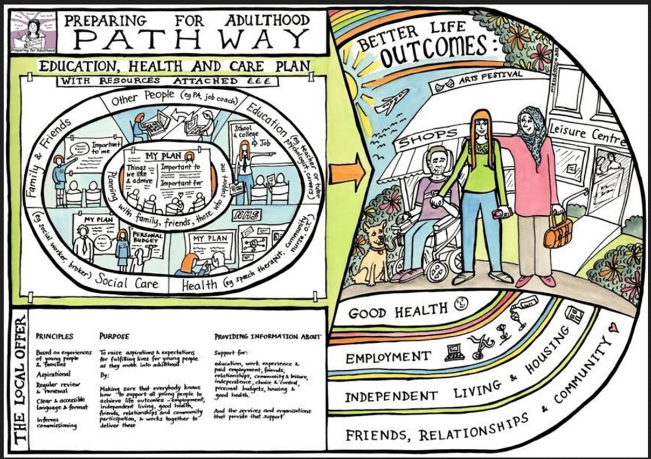

In College we work on preparing our students for adulthood through our four curriculum areas:
- Community inclusion
- Employability
- Independent living
- Health and Wellbeing
These curriculum areas are linked to the preparation for adulthood outcomes. We ensure that the education that our young people receive is adapted to meet their individual needs and relevant to the demands and contexts of both their local communities and the wider world.

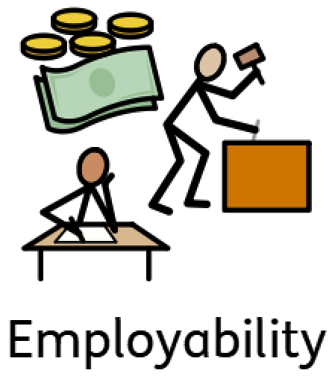
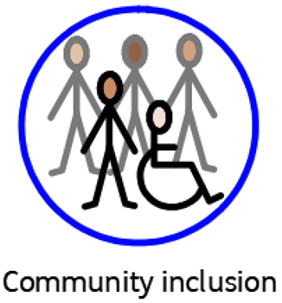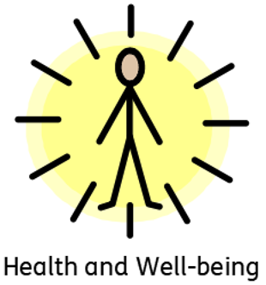
Employability statement of intent
We work with students and families to ensure that tasks and sessions are developed to be inclusive, purposeful, and meaningfully involve all of students regardless of their level of need.
There are planned and bespoke opportunities for students to develop life skills and work-related experiences on and off site. On site we have access to the Farm, the Trees café and shop, site related work, reception and kitchen. Off site we work with local retailers and employers to facilitate supported and independent work experience and work placements.
The key curriculum intents are to ensure that:
- All students participate in activities that are meaningful
- All students engage and enjoy their learning
- All students have opportunities for self-advocacy
- All students contributions are valued
- All students make functional application of their numeracy and literacy skills
- All students engage in and learn from the Skills Builder program in readiness for
employment, further education voluntary work and being active and fulfilled
members of their own community

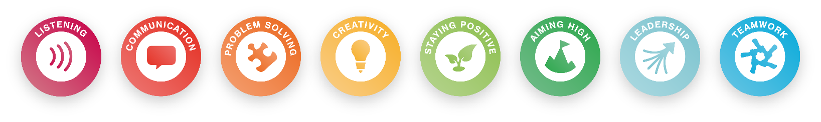
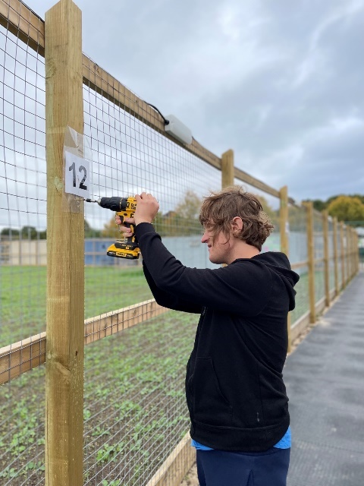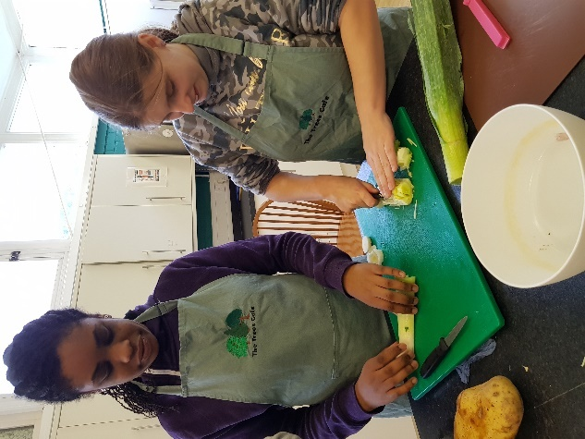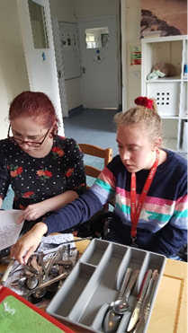

Community inclusion statement of intent
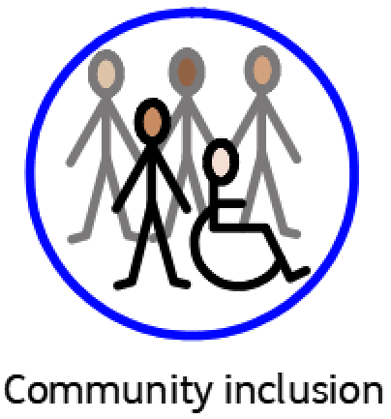
We work with students and families to develop interests through regular community visits and our enrichment curriculum.
We have daily fitness sessions through the Saints foundation, Forest school sessions, options from Newsletter editor through to Boxing and a wide range of Friday afternoon clubs and opportunities for Year 14 students to undertake Bronze Duke of Edinburgh award
All of which students advocate for when able to do so, to design their own timetable’s mixing with students across the whole site and on site adult day services.
The key curriculum intents are to ensure that:
- All students have a chance to advocate through expressing preferences or making choices about what they do
- All students will be supported with developing and maintaining friendships
- All students will have supported access to events and facilities in their own local communities
- All students will be able to contribute to society and their community in meaningful and enjoyable ways
- All students will have Relationships and Sex education at the appropriate developmental level, and learn how to keep themselves and others safe
- All students, through the range of opportunities given to them, will be able to identify ways that they can occupy themselves as an adult
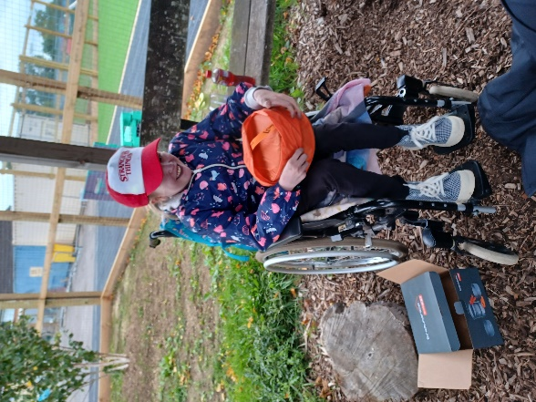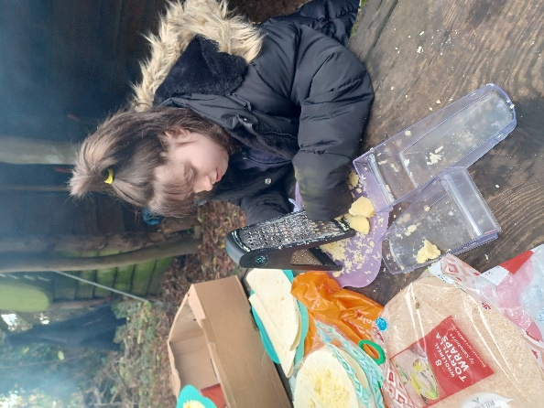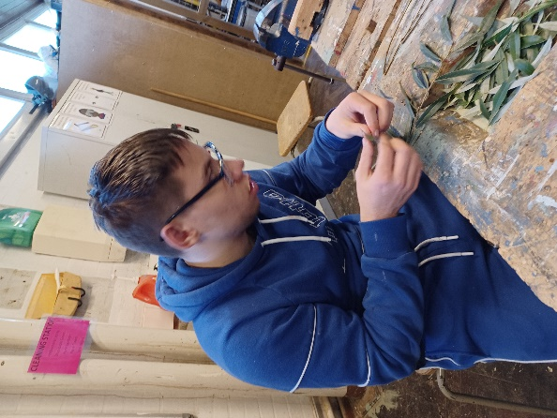
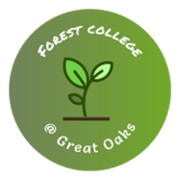
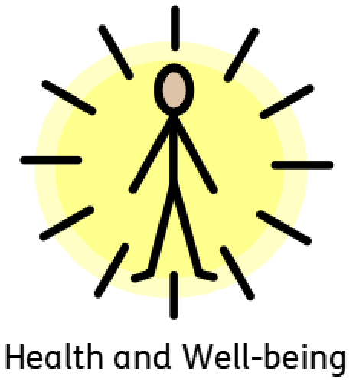
Health and wellbeing statement of intent
We work with students and families to support their transition from children’s to adults services for health and therapy.
All students are supported to manage their own health as they move into adulthood. Education professionals use person-centered approaches and work in partnership with health and social care colleagues as part of the EHCP planning process.
The key curriculum intents are to ensure that:
- All students will work on how to stay healthy through diet and learning to prepare simple healthy meals
- All students will engage in a range of physical activities, including yoga, boxing and meditation
- All students will undertake So Safe work to keep them safe in a range of contexts
- All students are supported to identify and advocate for their own needs
- All students are supported in understanding their own uniqueness and developing and maintaining positive self esteem
- All students are supported in taking risks, making mistakes and developing resilience in safe and supportive way

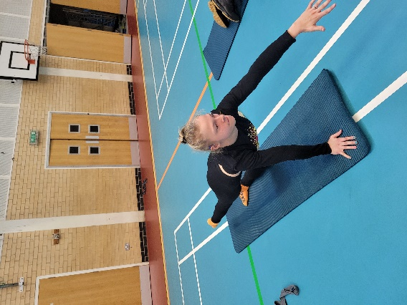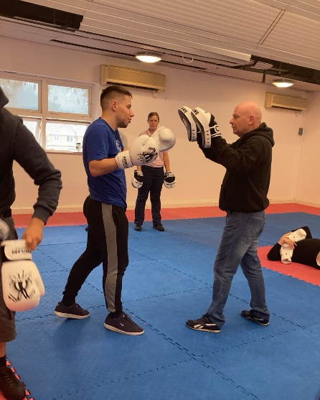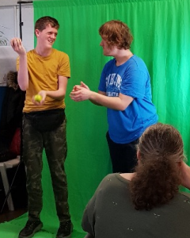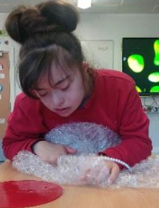
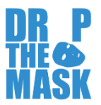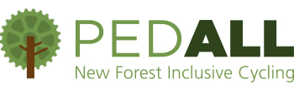

Independent living statement of intent
We work with students, families, and other services to support them in preparing for independent living and or reducing their need for support from others.
All students are supported in preparing for independence, whether they are going to move onto living independently, remain with family or supported living. This will involve specific task-based learning, real life situations and use of our Life skills flat and the wider community.
The key curriculum intents are to ensure that:
- All students are in control of their own life
- All students have aspirational targets for independence
- All students will work on functional tasks in the Life skills flat and be supported to generalise these skills into home setting
- Students that it is relevant for will be supported with budgeting and managing money
- Students it is relevant for will be supported in e form filling and accessing the online world
- Students it is relevant for will be supported with travel training
- Students that have chosen to, will complete the Chef academy option
- Students that have chosen to, will work in the Pop up shop hosted by Flourish, others will come as customers and or prepare items to sell in enterprise sessions
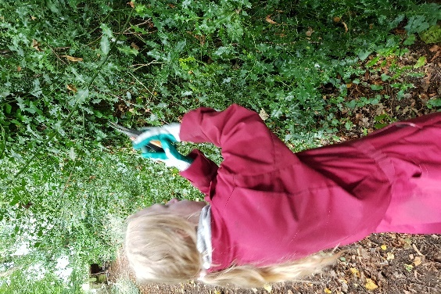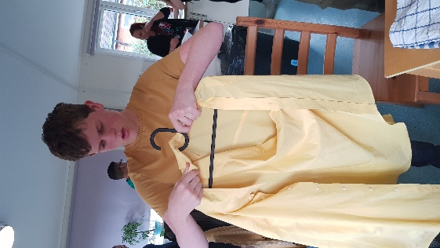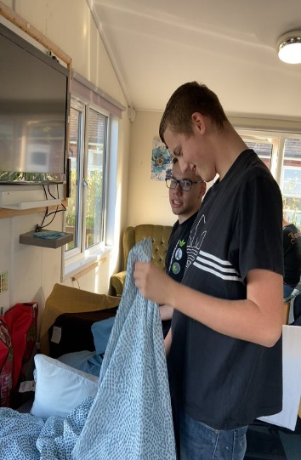

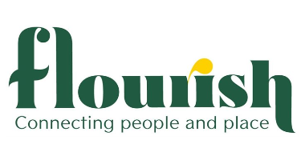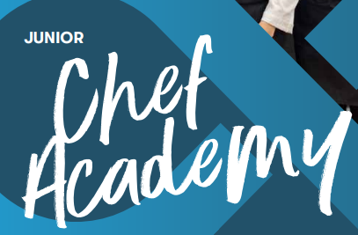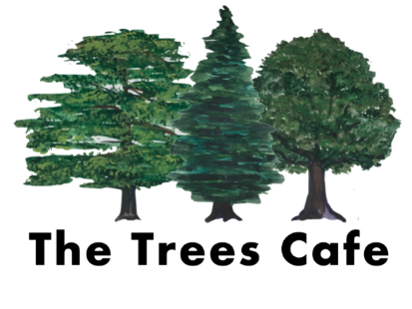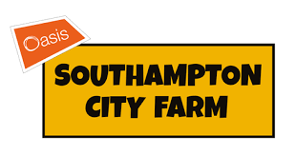

Assessment and accreditation at Great Oaks College
OCR
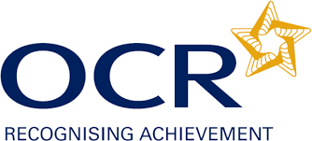
All young people are entered for OCR Life and Living Skills accreditation of the work and sessions that they undertake. These are nationally recognised accreditations and allow our young people to gain meaningful accreditation celebrating their successes throughout the time they are with us. The accreditation recognises achievement within the wide range of needs of our students.
Live and Living skills is a foundation learning qualification is accredited on the Qualifications and Credit Framework (QCF) and is available at Entry Level 1, 2 and 3.
It offers many ‘bite-sized’ units across a broad range of skill areas.
We build our sessions and their curriculum around the students’ needs and the OCR framework provides opportunities for us to accredit the learning. Our students drive the learning and the curriculum they receive and accreditation is the end result.

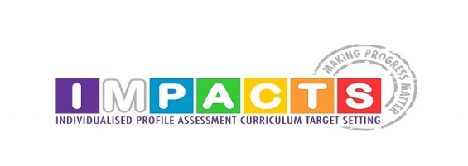
ImPACTS@GreatOaks – ImPACTS is an assessment, monitoring, target setting and implementation tool that allows the teaching and assessment of the developmentally young and will be used for students in Great Oaks College that have come to sue from Pathways 1.
It is written and developed by Rosewood school who we share the following aim with;
“We believe that in order to provide an effective learning environment it is necessary to have a detailed and shared understanding of a learner’s needs.”
A detailed assessment of where a young person is enables us to meet them there and plan for the small steps needed to enable them to make progress.
ImPACTS Curriculum
Each key skill area has an accompanying suggested curriculum, this can be used to inform the development and writing of age respectful and developmentally appropriate schemes of work.

Self-assessment clipboards and IEPs
We believe it is important for our students to be actively engaged in reviewing their learning and planning their next steps.
Students will have their Individual education plans and targets on a clipboard. The targets are developed as small steps towards their EHCP outcomes. Taking it with them as they travel around the site for options. Encouraging students to reflect on their progress.

All students will have time in the week to review their progress and plan their next steps, identifying a key area of focus.

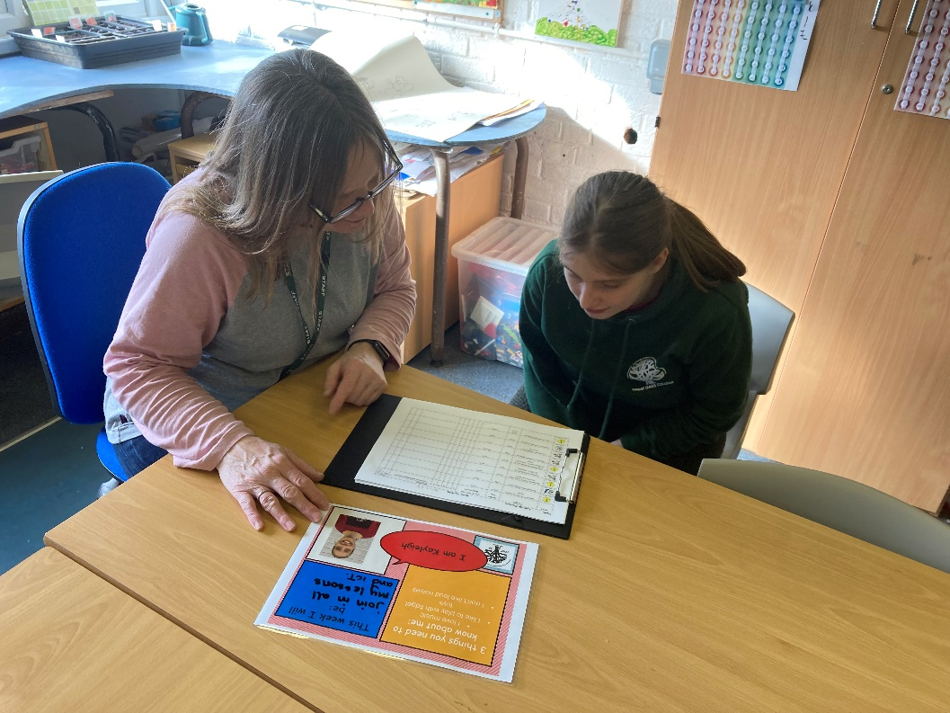

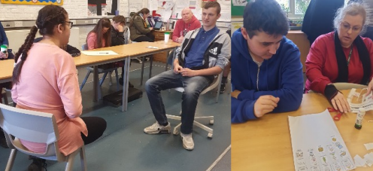

Passport to adult living (PAL)
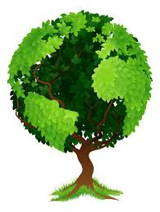
The PAL will bring together all the key information about a student. We engage with the student, family and other services such a therapy and social acre to collate the information. This will be shared with adult providers, to help inform what we believe the next steps on the young person’s Pathway to Adulthood will be.
Additional information will support how adult services develop their approaches and provision to meet the needs of our young people. And to provide key areas of focus to support young people with.
PAL content
- Front cover with pie chart of PfA approach for the individual and a summary statement
- IEP targets
- Individual Behaviour Plan
- Communication passport
- Pen portrait
- Therapy input
- Copy of last report
The charts below provide a visual representation of how we ensure we are following the right path for each young person.
Year 12 student who will have a term of focusing on all four outcomes, as we asses and review with the student and family what are the key areas to focus on.
Year 14 student about to leave to go onto two days at Southampton City Farm as a volunteer and 3 days a Totton College to continue with his education with a suggested focus on managing on accessing the community and skills for independent living.

Leavers destinations
2019 | Yr 14 Totton College Live Skills pathway  Yr 14 City College to study an NVQ  Yr 14 Minstead Trust  Yr 14 to Thrive adult day service  Yr 14 to Way ahead adult days service  Yr 14 to Avenues 19-25 at Rosewood to continue education  Yr 13 to Yeovil
2020 | Yr 13 1 Albany Farm home for residential 24 hour supported care  Yr 13 1 Fortune Centre New Forest  Yr 14 1 Outreach and Way ahead  Yr 14 6 Totton College Live Skills pathway
2021 | Yr 13 1 Elective home education  Yr 14 7 Totton College Live Skills pathway  Yr 14 1 Newbury college  Yr 14 Totton NVQ music
2022 | 1 yr 14 Thrive  6 Yr 14 Totton College Live Skills pathway  1 Yr 13 City College

